La RAF durant la 2e Guerre Mondiale Les Squadrons

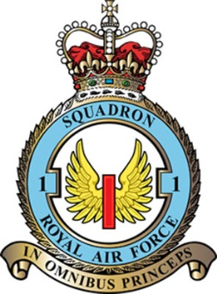 | 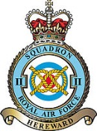 | 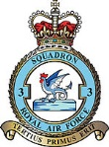 | 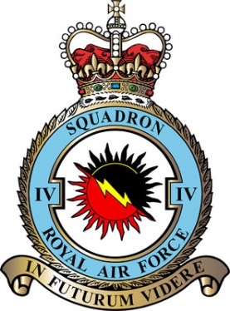 | 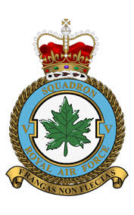
Code NA 11-38-09-39-  JX 06-40-1951 | Code KO 11-38/ 5-41  XV 5-41 1943  OI 1946 | Code OP 38-39  QO 39-44  JF 1944 1946
Hurricane  Typhhon  Spitfire | Lysander 38-42  Defiant I 40-41  Tomahaxk I 41-42  Mustang I 42-44  Spitfire XXIV 44-51s | Gladiator I 38-39  Hurricane I 1938 +39-41  Hurricane II A 4.41-11.41  Hurricane II C 4.41 -11.43  Typhoon IB 02.43-04-44  Tempest 02.44-1948-

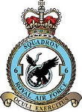 | 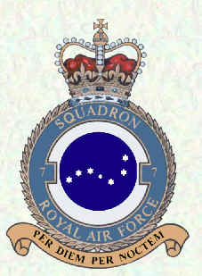 | 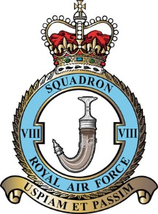 | 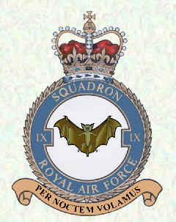 | 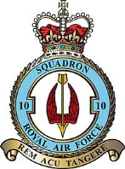

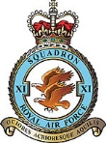 | 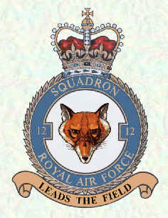 | 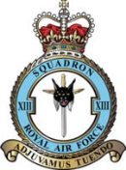 | 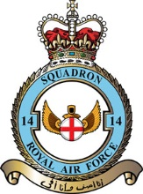 | 